First I have Created the Package for Titanic model

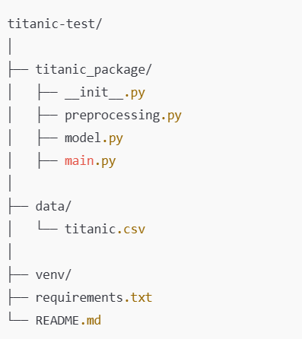

* Run the Docker Desktop Application
* Create a Dockerfile under titanic-test and copy and paste following code

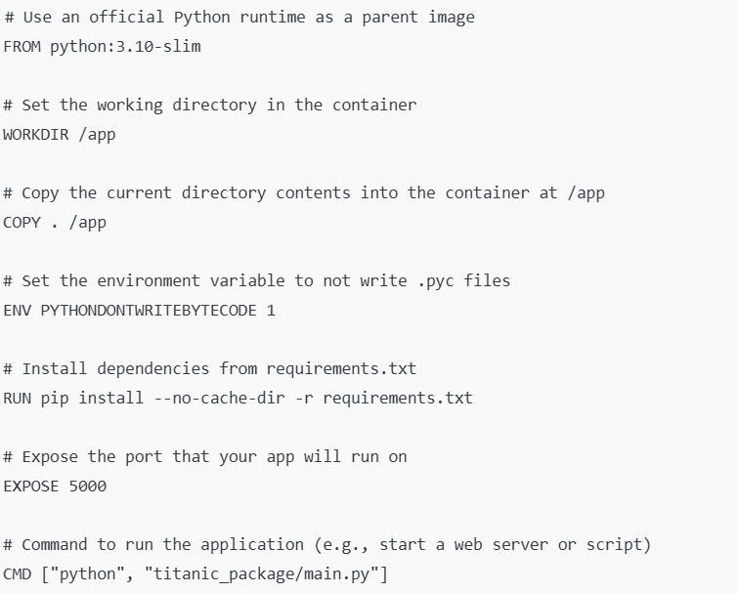

* After writing the docker file code
* Run docker desktop application left side down the corner play and pause button
* Build the Docker image cmd code : docker build -t titanic-model .
* This will create docker image and then you need to run
* Run the Docker Container cmd code : docker run -d -p 5000:5000 titanic-model
* able to access your app at <http://localhost:5000>
* To list all the docker cmd code : docker ps
* If you want to stop the container: docker stop <container_id>